**Project Report Template**

1. **INTRODUCTION**
   1. **OVERVIEW:**

Tragedy of flight gives the information about the airplane crash (accidents)

and we have to present a charts for the given data sheet.

* 1. **Purpose**

Aviation accident analysis is performed to determine the cause of errors once an accident has happened.

1. **PROBLEM DEFINITION & DESIGN THINKING**

Brainstroming map:

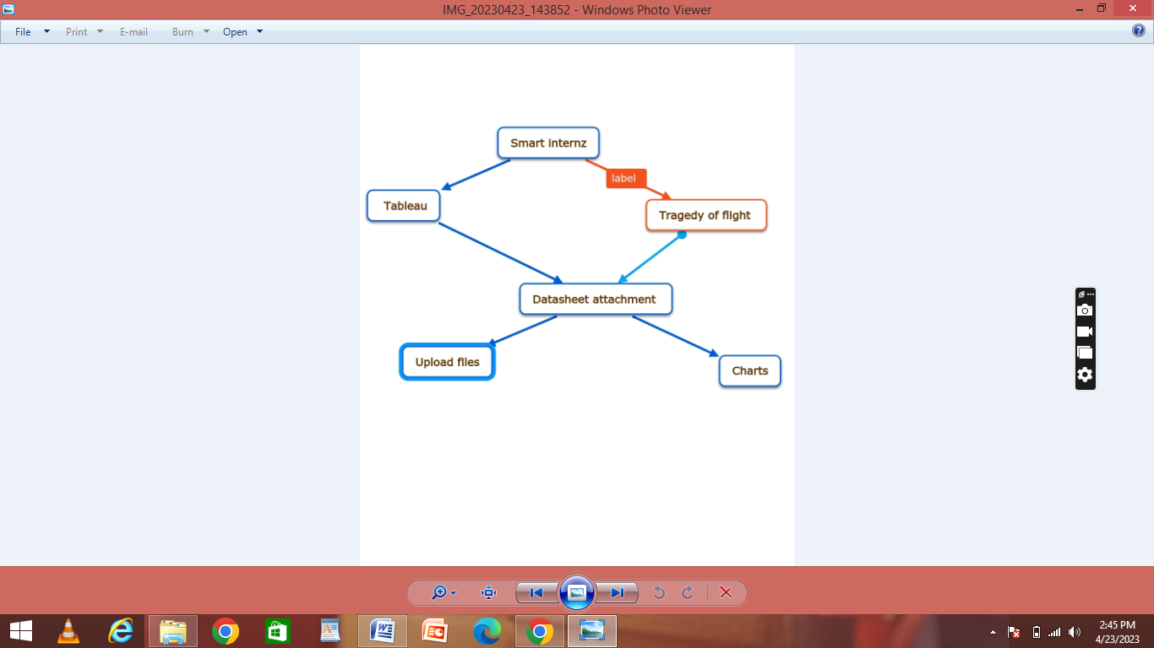

Empathy map:

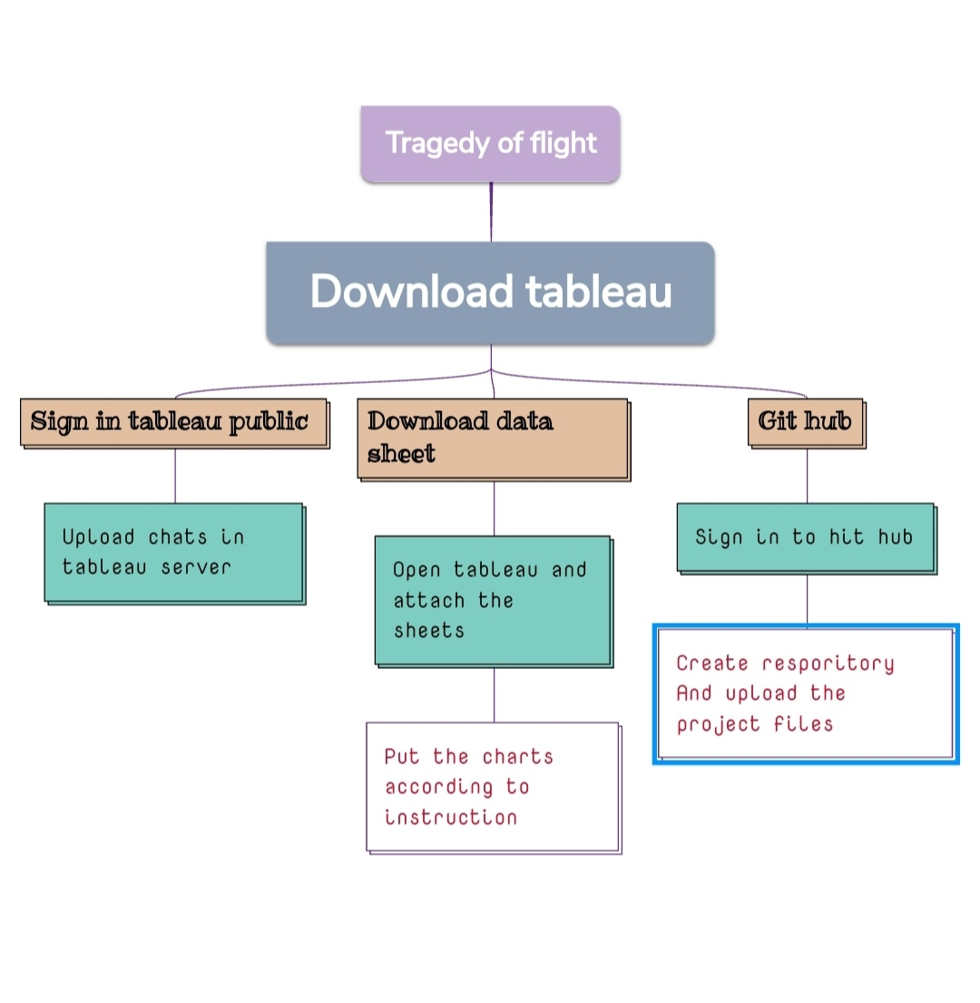

**RESULT**

Output of the project

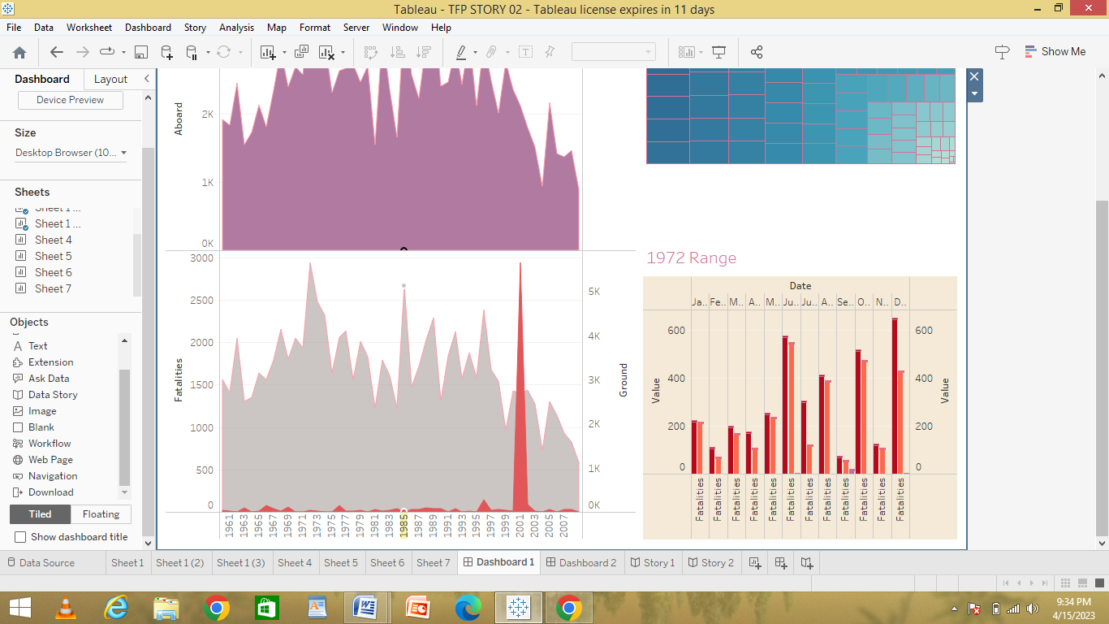

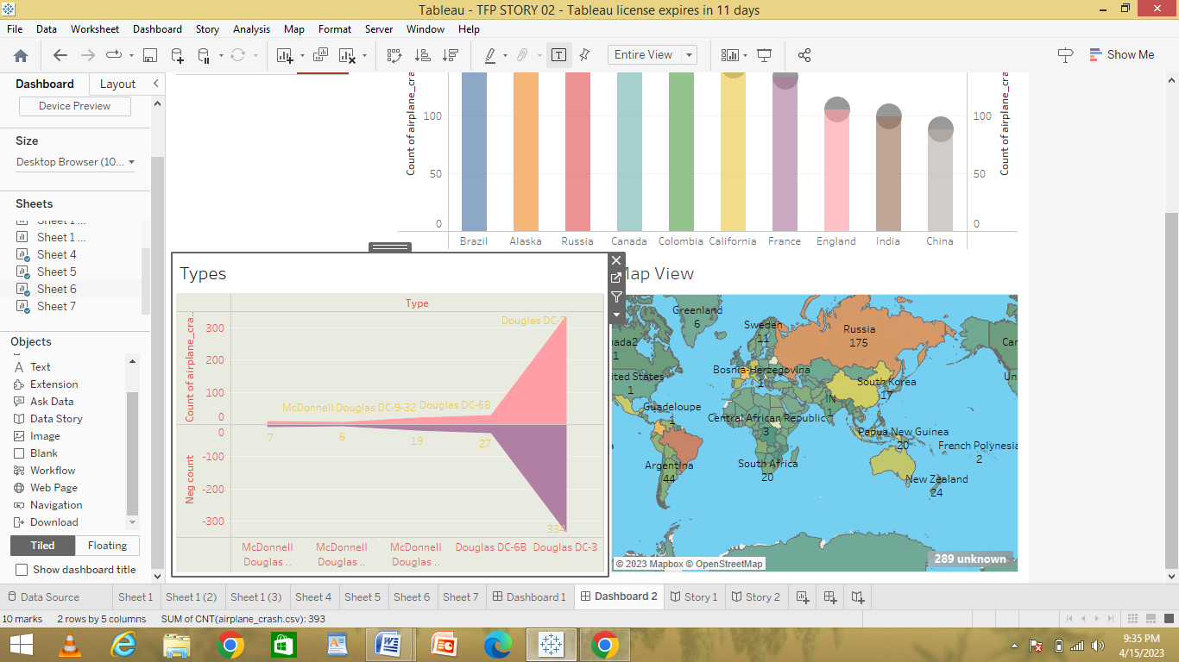

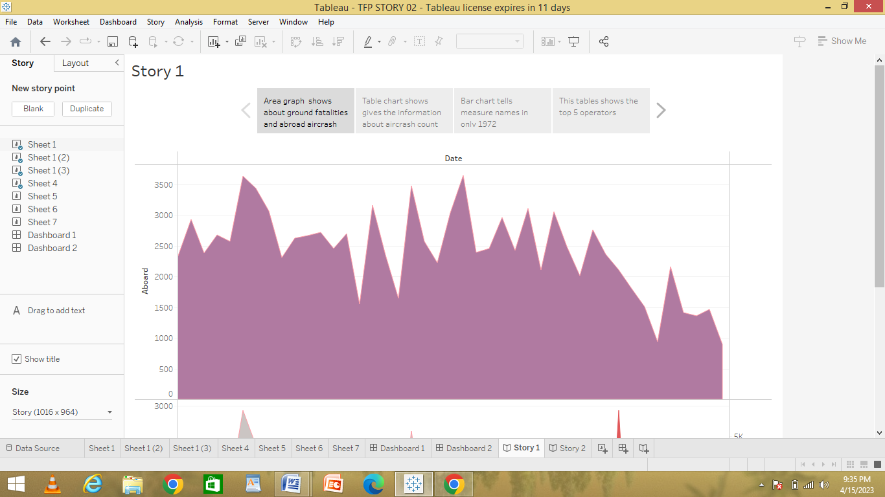

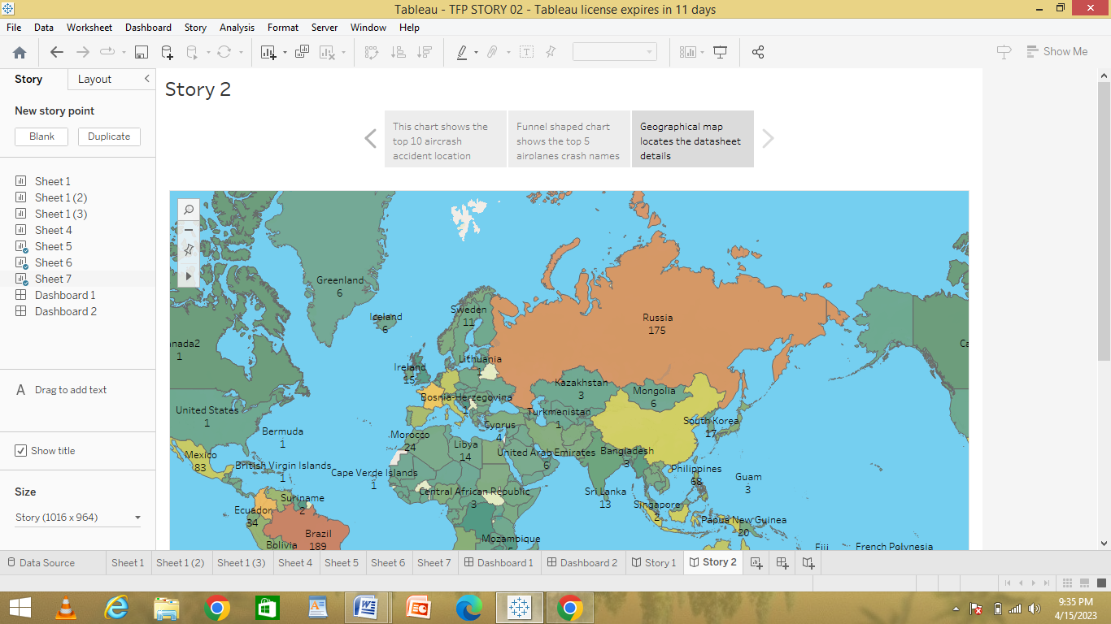

**ADVANTAGES :**

* Based on these analysis we can reduce or find solutions to reduce air craft accidents

**DISADVANTAGES:**

There is an some server problem in crating the projects

**APPLICATIONS:**

* We can use this analysis in airports

**CONCLUSION:**

Atlast I conclude that by doing this project I have gain knowledge

About airplane crash